A Cross-Institution Alignment Protocol for Fatigue Monitoring: A Normalised Lifetime Axis and a Scale-Free Health Indicator
Chengxuan YANG^{a,*}, Huaiwen GOUª, Kuiting LIª, Jixiang TANGª
ª School of Mechanical Engineering, Xi’an Jiaotong University, Shaanxi Xi’an 710049, China
Abstract. Fatigue monitoring records from different institutions cannot be placed on one chart. The campaigns are independent, their acquisition intervals and loading types differ, and alarm thresholds are calibrated per specimen. This paper reports a protocol that makes them comparable along two axes. The horizontal axis is a normalised lifetime fraction, taken from the documented acquisition interval and checked against the testing machine's own cycle counter. The vertical axis replaces the absolute threshold with SNHI (self-normalised health indicator), a scale-free indicator equal to the lifetime fraction at which the self-normalised cumulative curve reaches x% of its final value. On 15 specimens compared by leaving one campaign out, the absolute-threshold rule raised no alarm for 40% of them, whereas SNHI returned a position for all of them and reduced the within-batch spread by a factor of 3.3. Applied to 29 acoustic-emission and 17 guided-wave specimens from two universities and three loading types, the institution accounts for 0.000 at $\text{x} \text{=} \text{50}$ (below 2.6% of permutations), and 0.057 at $\text{x} \text{=} \text{85}$ (not distinguishable from the permutation baseline), against permutation medians of about 0.02, while the differences between specimens are retained.
Keywords. cross-institution alignment, lifetime normalisation, scale-free health indicator, acoustic emission, guided waves, fatigue monitoring

Introduction
Stiffened composite panels in aircraft accumulate fatigue damage under cyclic loading and may also suffer foreign-object impact, so condition-based maintenance requires structural health monitoring (SHM) to track damage growth over the service life.^{[1]}
Acoustic emission (AE) and guided-wave (Lamb wave) inspection are two widely adopted modalities for this task,^{[2][3]} and distributed fibre-optic strain sensing follows them.^{[4]} All three read the record against an absolute threshold, with an alarm raised once a monitored quantity exceeds a value fixed in advance for the specimen or for the campaign.^{[5]}
When records from several campaigns are brought together, as happens more and more often in data-driven SHM,^{[6]} two obstacles appear. The first concerns the horizontal axis, because the campaigns were run at different times, with different acquisition intervals and loading types, so they share no wall-clock axis on which damage progress could be compared and one has to be defined. The second concerns the vertical axis, because absolute magnitudes are not transferable. The gain and the detection threshold are set per campaign, so a threshold calibrated on historical specimens will not carry over to a new one.^{[2][5]}
Normalised criteria such as monotonicity, trendability and prognosability are already used to rank candidate indicators,^{[7]} and multi-institution datasets are increasingly assembled,^{[8][9]} so comparability across institutions is a practical requirement rather than a theoretical one.
This paper addresses both obstacles with a protocol that renders data from different institutions mutually comparable, rather than with another damage-detection algorithm. The horizontal axis turns every measurement into a normalised lifetime fraction, taken from the acquisition interval documented in the experiment sheets, and the vertical axis replaces the absolute threshold with a scale-free indicator, SNHI, the lifetime fraction at which the self-normalised cumulative curve has reached x% of its final value. The protocol is demonstrated on 29 acoustic-emission and 17 guided-wave specimens from the publicly available ReMAP dataset,^{[10][11][12][13]} recorded with a Vallen and a Mistras system.

The Cross-Institution Alignment Protocol
Two axes have to be made comparable before records from different institutions can be plotted together, and the protocol treats them separately. 2.1 defines the horizontal axis, a normalised lifetime fraction obtained from the acquisition documentation. 2.2 defines the vertical axis, a scale-free indicator that removes the dependence on any absolute magnitude. Figure 1 summarises the flow.
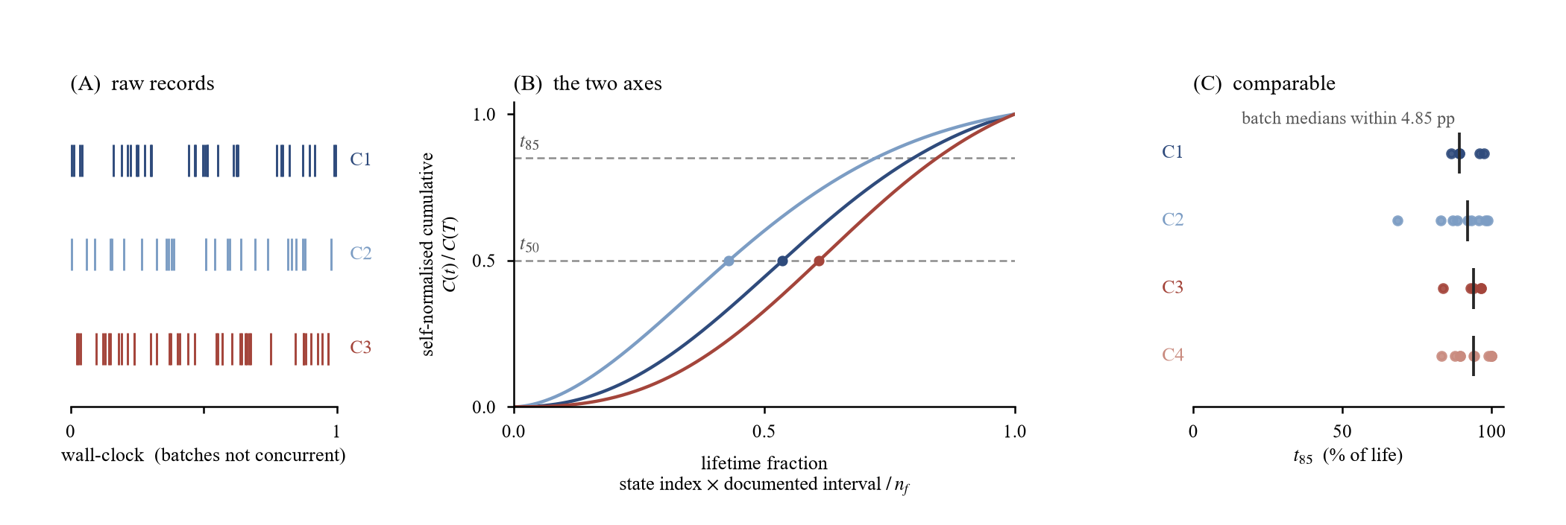
Figure 1. The two axes of the protocol.

Lifetime Axis Reconstruction
The four campaigns analysed here were published as separate dataset records.^{[10][11][12][13]} They were run at different times, they do not overlap, and no specimen was measured by more than one laboratory. The labels C1 to C4 are introduced in this work and group the campaigns by loading and instrumentation; they do not follow the series numbering of the records. Their absolute time stamps therefore cannot be placed on a common scale. What they do share is the specimen itself, a single-stiffener carbon-epoxy panel, 165 mm by 243 mm, carrying acoustic-emission sensors, a guided-wave transducer array, fibre Bragg gratings (FBG) and distributed strain sensing (Figure 2).
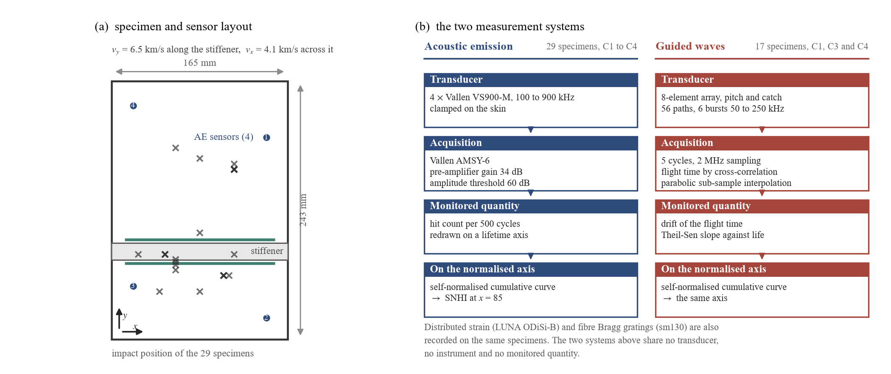
Figure 2. Specimen and instrumentation.
Two further differences make a wall-clock axis unsuitable in principle. The acquisition interval also differs, at 5000 cycles in the campaigns of the first laboratory and 5200 in those of the second, and the loading covers constant, variable and spectrum amplitude, so a given span of wall-clock time corresponds to a different amount of fatigue life in each campaign.
For these reasons the horizontal axis is defined as a normalised lifetime fraction,
$\text{lifetime fraction}\text{=}\frac{\text{state index}\text{×}\text{documented acquisition interval}}{{\text{n}}_{\text{f}}}$ (1)
with ${\text{n}}_{\text{f}}$ the number of cycles at failure of the specimen and the state index the position of the record in the acquisition sequence. Both inputs are taken from the acquisition documentation rather than from the stored time stamps.
The definition can be checked against an independent record. Each testing machine kept its own cycle counter, from which the cycles at every acquisition session can be recovered. Along the record of each specimen, the lifetime fraction of Equation (1) and the machine cycle count order the acquisition states identically for 13 of the 14 specimens of the second laboratory, with a rank correlation between +0.993 and +1.000; the exception is a specimen whose session time stamps are out of order.

The Scale-Free Indicator SNHI
Indicators used in fatigue monitoring are almost always read against an absolute threshold, and an absolute threshold has to be calibrated specimen by specimen. That this cannot be met on the present data is shown by four independent indications (Figure 3).
- Alarm time (Figure 3a). A single threshold applied to the AE hit rate of every specimen places the alarm at life fractions that spread over 46.2 percentage points in the median configuration.
- Distributed strain (Figure 3b). The strain at failure recorded by the distributed fibre-optic sensor differs between specimens by a factor of 6.57 to 7.34.
- Causal normalisation (Figure 3c). Normalising the curves at anchors at 5, 10, 20, 30 and 50% of life does not make the failure values coincide, the coefficient of variation staying between 0.97 and 1.62.
- Guided waves (Figure 3d). With the guided-wave threshold set from information available before the decision, the campaign retains 0.036 to 0.409 of the variance over the fifteen configurations tested, and exceeds its own permutation median in twelve of them, so the campaign effect is comparable with the specimen effect.
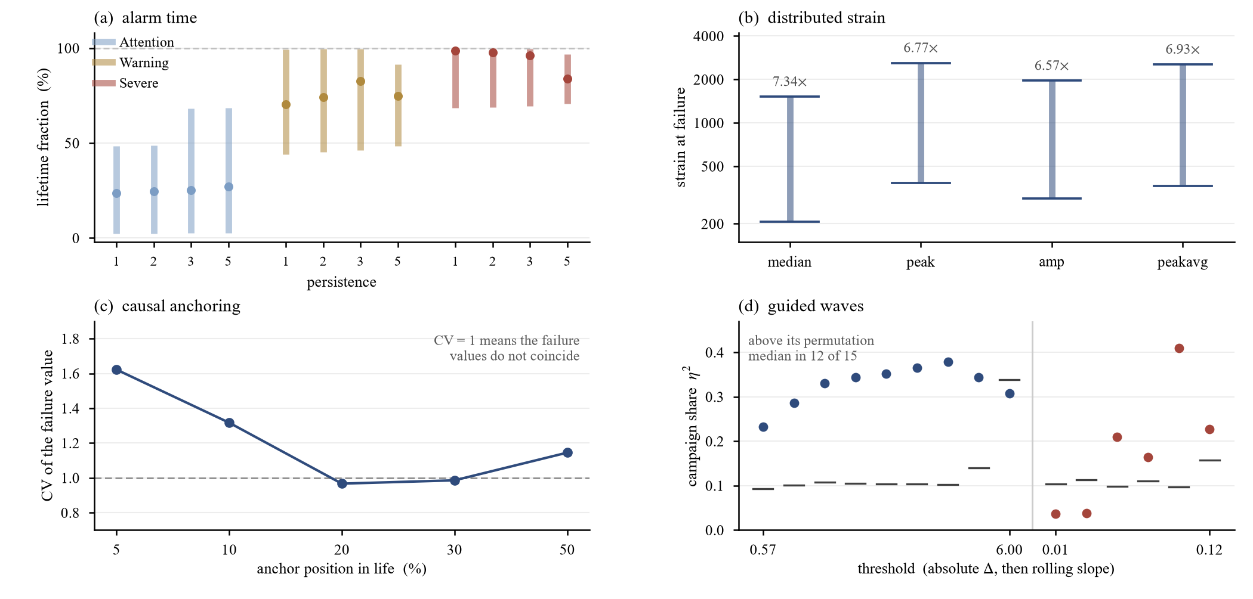
Figure 3. Why an absolute threshold does not transfer.
One number states the problem most directly. Within one batch the AE hit count at failure, per 500 cycles, ranges from 918 to 46,221, a factor of 50.3, so a threshold set on one specimen will either miss or pre-empt its neighbours, and no adjustment of the threshold avoids this.
The vertical axis is therefore defined by a scale-free quantity. The self-normalised cumulative curve of a monitored quantity is its running total divided by its final value; the curve rises from 0 to 1 over the life of the specimen. The indicator SNHI is the lifetime fraction at which this curve reaches x% of its final value:
$\text{SNHI}\left(\text{x}\right)\text{=}\frac{\text{lifetime fraction at which the self−normalised cumulative curve equals }\text{x}}{\text{100}}$ (2)
Two values are used in this work, $\text{x} \text{=} \text{50}$ and $\text{x}\text{ = 85}$. The definition refers to a fraction of the final value and to a position on a normalised axis, so it is invariant to bin width, frame rate, sampling rate and record format and insensitive to the absolute gain and threshold settings, which is what the absolute-threshold rule is not.
SNHI is a descriptor of the record, not an alarm rule. The normalisation uses the value the cumulative curve reaches at the end of the record, so SNHI is defined retrospectively, and a forward alarm would need that value in advance. Re-anchoring the same curves at 5, 10, 20, 30 and 50% of life, which is available before the decision is taken, does not make the failure values coincide (Figure 3c). The retrospective normalisation is what makes the comparison possible, not a convenience. Where an alarm should be placed is a separate question.

Experiments and Results

Comparison with Absolute-Threshold Alarming
Two rules were compared on the 15 specimens of the variable-amplitude and spectrum-loaded campaigns, for which both produce the same quantity, a lifetime fraction. They are not the same kind of object. (A) is a decision rule, which may abstain; (B) is a descriptor, defined for every specimen that recorded any emission and therefore unable to abstain. The comparison is about the position reported, not the ability to decide.
Rule (A) is the conventional one. It takes the AE hit count per 500 cycles and alarms when it exceeds the median hit count at failure of the remaining campaigns, smoothed over three bins. Rule (B) is SNHI at $\text{x}\text{ = 85}$ on the same cumulative curve.
Rule (A) abstained on six of the fifteen specimens; of the nine alarms it did raise, seven fell inside the first 7% of life, at the noise floor of the record. The apparent between-batch agreement of 4.6 percentage points is an artefact of those six abstentions and of those seven early alarms rather than a result. Rule (B) reduced the within-batch spread of the reported position from 60.7 to 18.5 percentage points, a factor of 3.3, with batch medians of 94.2% and 91.7%; counting the six abstentions of (A) as an alarm at the end of life raises its spread to 69.0 points.
The threshold of (A) was not chosen adversarially. Of the 26 rules tested, spanning scaled leave-one-campaign-out thresholds from 0.02 to 3, pooled and early-life quantiles, and thresholds referenced to each specimen's first 10% of life, the smallest number of abstentions is one, reached only at thresholds that place the median alarm inside the first 3% of life.

Exclusion of Failed-Sensor Paths
A transducer that breaks or disbonds invalidates every path using it as actuator or receiver, from the cycle of the event onward, accumulating over repeated events. Seven specimens lose 14 to 56 of the 56 paths, one losing all of them at 47% of life, so only its earlier record enters its fit. Recomputing the slopes without them leaves the counts unchanged at 17 of 17 positive and 16 with a lower bound above zero. Six gain 5% to 40% and the seventh loses 80% but stays positive at [+0.0009, +0.0088]. Five further specimens record a failure with no sensor index and retain all paths.

Validation on Two Independent Systems
Acoustic emission. The 29 specimens of the four campaigns were processed with $\text{x}\text{ = 85}$ on the cumulative hit count (Table 1). The four campaign medians of the alarm position span 4.84 percentage points against a within-batch spread of 14.76; removing the single variable-amplitude specimen of the first campaign brings the between-batch spread to 1.94 points. The alignment statistic is the share of the total variance explained by the grouping. By campaign (C1 to C4) the share is 0.071 against a permutation median of 0.090; by university (Delft, C1 and C2 together; Patras, C3 and C4 together) it is 0.000 at $\text{x}\text{ = 50}$, below 2.6% of the shuffled draws, and 0.057 at $\text{x}\text{ = 85}$. As a control, replacing the hit count by the cumulative energy raises the campaign share at $\text{x}\text{ = 50}$ from 0.054 to 0.280, above a permutation median of 0.088.
Table 1. Acoustic emission across campaigns; variance decomposition.
campaign | laboratory | $$\text{n}$$ | median ${\text{t}}_{\text{50}}$ (%) | median ${\text{t}}_{\text{85}}$ (%) | range of ${\text{t}}_{\text{85}}$ (pp)
C1 | Delft | 5 | 68.4 | 89.2 | 11.00
C2 | Delft | 9 | 61.6 | 92.1 | 30.20
C3 | Patras | 5 | 68.2 | 94.0 | 12.80
C4 | Patras | 10 | 55.6 | 94.0 | 16.72

quantity | grouping | $${\text{η}}^{\text{2}}$$ | Null median | $\text{p}$ (lower tail)
cum_hits ${\text{t}}_{\text{85}}$ | campaign | 0.071 | 0.091 | 0.386
cum_hits ${\text{t}}_{\text{85}}$ | university | 0.057 | 0.018 | 0.781
cum_hits ${\text{t}}_{\text{50}}$ | university | 0.000 | 0.017 | 0.026
cum_energy ${\text{t}}_{\text{50}}$ (control) | campaign | 0.280 | 0.088 | 0.037*
p is the fraction of 20,000 shuffles of the group labels that give a smaller variance share, with the group sizes held fixed. * The control row reports the upper tail, i.e. the fraction of shuffles that give a larger share.
Guided waves. The 56 paths of the 17 specimens with guided-wave coverage were reduced to the time-of-flight drift (Table 2), estimated by cross-correlating each record against a reference with parabolic interpolation, which repeats to within 0.190 microseconds against 1.378 for peak picking. The slope is taken with the Theil-Sen estimator, preferred to least squares because the late-life records are noisier, the median point-to-point jump being 0.755 microseconds against 0.163 in the first 15% of life. The slope is positive for all 17 specimens and the confidence lower bound above zero for 16 (values and units in Table 2). Under the same decomposition the three campaigns carry a share of 0.128 against a permutation median of 0.095, and the two laboratories 0.000, below 0.4% of the shuffled draws.
Table 2. Guided-wave drift across campaigns; variance decomposition.
campaign | laboratory | $$\text{n}$$ | median slope (microsecond / 100% life) | Kendall $\text{τ}\text{ > 0}$
C1 | Delft | 5 | +0.0159 | 5/5
C3 | Patras | 5 | +0.0121 | 5/5
C4 | Patras | 7 | +0.0244 | 7/7

quantity | grouping | $${\text{η}}^{\text{2}}$$ | Null median | $\text{p}$ (lower tail)
TOF drift slope | campaign | 0.128 | 0.096 | 0.612
TOF drift slope | university | 0.000 | 0.029 | 0.004

The two systems compared. The two systems share no transducer, no instrument and no monitored quantity. Yet for the quantity each reports, the acoustic-emission position at $\text{x}\text{ = 50}$ and the guided-wave drift slope, both place the share of variance attributable to the university at 0.000, below 2.6% and 0.4% of the shuffled draws respectively, while the differences between specimens are retained (Figure 4).
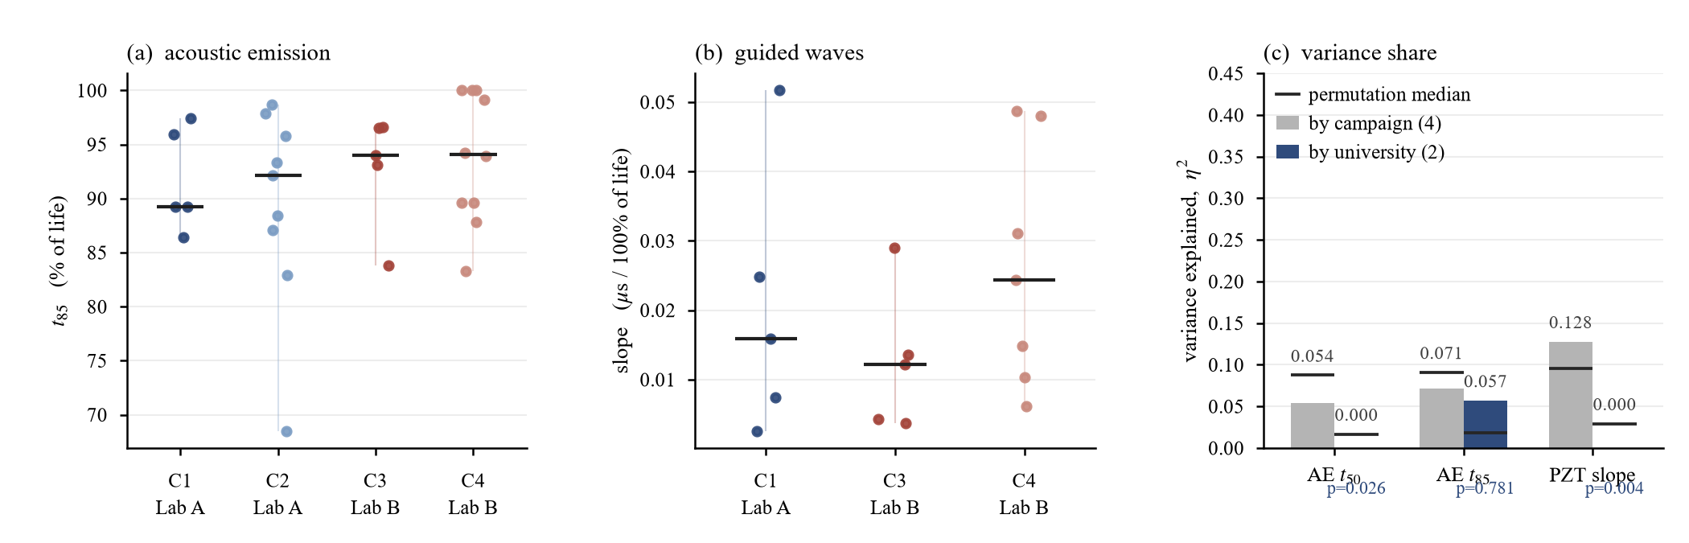
Figure 4. Two independent measurement systems compared.

Agreement Across Four Modalities on the Same Specimen
A sharper test than the comparison in Section 3.3 is available on the five specimens that carry four modalities at once, acoustic emission, guided waves through the transducer array, fibre Bragg gratings and distributed fibre-optic strain, on which four physically different measurements of one fatigue process were recorded at the same acquisition states. Each was reduced to a cumulative curve over the acquisition index, normalised by its own final value as in Equation (2), and the lifetime fraction at which it reaches half of that value, $t_{50}$, taken as the position of the process (Figure 5).
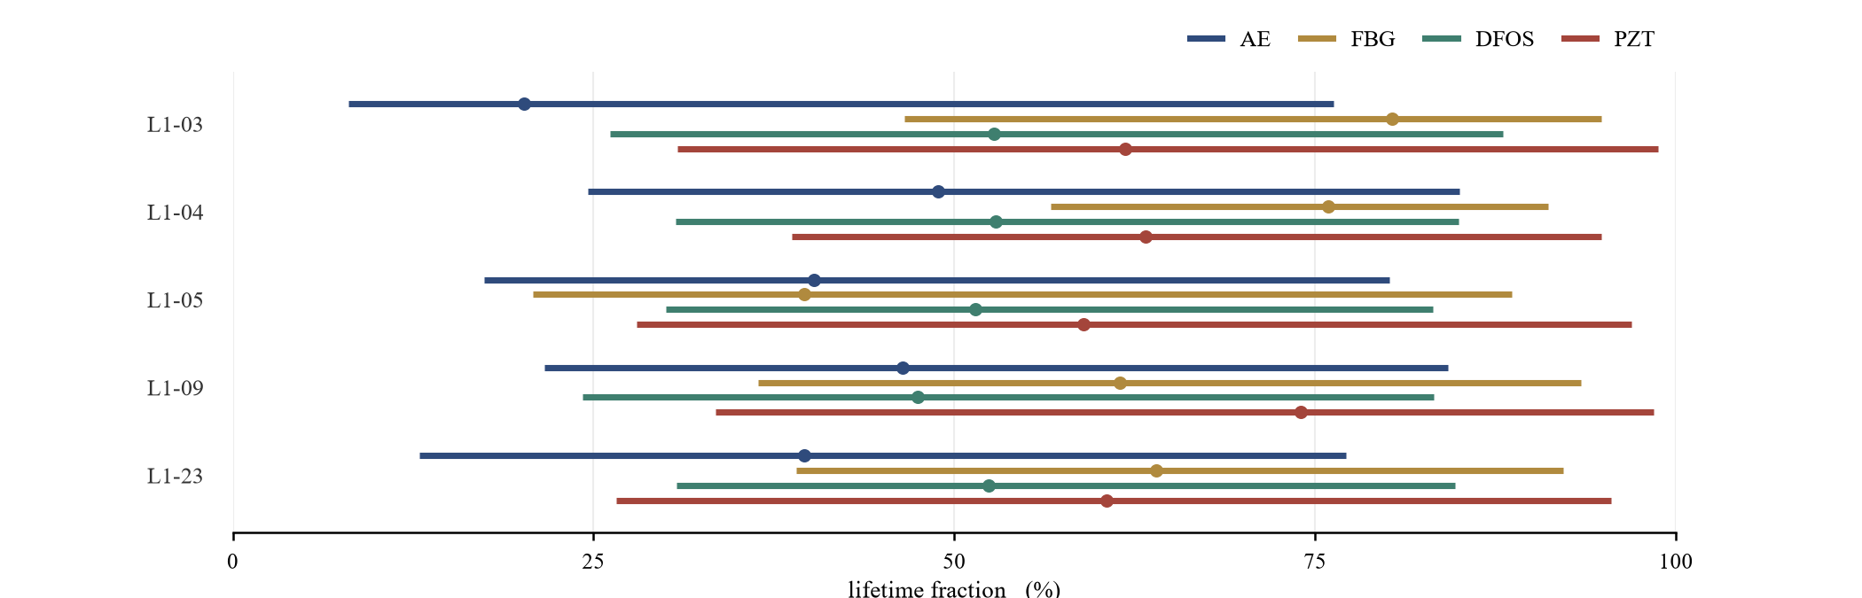
Figure 5. Four modalities on the same specimens.
Three observations follow. First, the four modalities order themselves alike on most of the set. Acoustic emission is the earliest indicator on four of the five specimens and distributed strain sensing on the fifth, guided waves follow, and the FBG indicator is the latest on four of the five, the single inversion being the FBG result of L1-05, whose $t_{50}$ lies at 39.6% of life against 64.0 to 80.4% elsewhere. Second, they differ in repeatability rather than in ordering, since distributed strain sensing places $t_{50}$ within 5.4 points across the five specimens, whereas the FBG indicator covers 39.6 to 80.4%. Third, their short-term fluctuations do not agree, the rank correlation over the six modality pairs falling between −0.556 and +0.667, with medians of −0.264 for the emission and FBG pair and +0.209 for the emission and guided-wave pair.
The protocol aligns the first two of these properties and not the third, which is what one expects from four sensors responding to four different physical quantities.

Conclusions
The protocol makes 29 acoustic-emission and 17 guided-wave records from two universities comparable along two axes. The lifetime axis is recoverable from the acquisition documentation alone and reproduces the testing machine's own cycle record, and on it the two quantities the protocol reports carry no measurable institutional share while the differences between specimens survive. The rule the protocol replaces does the opposite. It stayed silent for two fifths of the specimens and, where it did trigger, fired at the noise floor, seven of its nine alarms falling before the emission had begun to grow. Three things the protocol does not do are worth stating. It aligns the position of an alarm rather than the time base of a single measurement, and the residual of the acoustic-emission localisation, which neither axis touches, differs between specimens and is largely attributable to a single channel offset. Nor is SNHI a forward alarm, since it is defined against the value the record reaches at its end. Where an alarm should be placed remains a separate question.

Data availability and Acknowledgement
The datasets analysed here are openly available in DataverseNL (doi:10.34894/QNURER, doi:10.34894/N2RWPR, doi:10.34894/WCDRLW, doi:10.34894/ABR2WX); the analysis scripts are available from the corresponding author.
The experimental data come from the publicly available ReMAP dataset, collected at Delft University of Technology and the University of Patras by the consortium of the European Union's Horizon 2020 research and innovation programme ReMAP (Grant Agreement Number 769288). This work was supported by the Shaanxi Provincial Innovation and Entrepreneurship Training Program for College Students (No. S202610698472).

References
- C.R. Farrar and K. Worden, An introduction to structural health monitoring, in: New Trends in Vibration Based Structural Health Monitoring, CISM International Centre for Mechanical Sciences, Springer, 2010, pp. 1–17.
- M. Wang, M. He, Z. Liang, D. Wu, Y. Wang, X. Qing and Y. Wang, Fatigue damage monitoring of composite laminates based on acoustic emission and digital image correlation techniques, Composite Structures 321 (2023), 117239.
- R.S. Panda, P. Rajagopal and K. Balasubramaniam, Characterization of delamination-type damages in composite laminates using guided wave visualization and air-coupled ultrasound, Structural Health Monitoring 16 (2) (2017), 142–152.
- L. Wong, N. Chowdhury, J. Wang, W.K. Chiu and J. Kodikara, Fatigue damage monitoring of a composite step lap joint using distributed optical fibre sensors, Materials 9 (5) (2016), 374.
- T.T. Assimakopoulou and T.P. Philippidis, Health monitoring of composite structures based on acoustic emission measurements, in: Fatigue Life Prediction of Composites and Composite Structures, Woodhead Publishing, 2010, pp. 466–504.
- S. Yang, M. Li, J. Liao, J. Wang, D. Zhao, Z. Li and Z. Wang, Predictive-SHM: An open-source, extensible software toolkit for multi-sensor structural health monitoring and time-series prediction, SoftwareX 35 (2026), 102732.
- A. Saxena, J. Celaya, B. Saha, S. Saha and K. Goebel, Metrics for offline evaluation of prognostic performance, International Journal of Prognostics and Health Management 1 (1) (2010).
- N. Yue, A. Broer, W. Briand, M. Rébillat, T. Loutas and D. Zarouchas, Assessing stiffness degradation of stiffened composite panels in post-buckling compression-compression fatigue using guided waves, Composite Structures 293 (2022), 115751.
- A. Broer, G. Galanopoulos, R. Benedictus, T. Loutas and D. Zarouchas, Fusion-based damage diagnostics for stiffened composite panels, Structural Health Monitoring 21 (2) (2022), 613–639.
- D. Zarouchas, A. Broer, G. Galanopoulos, W. Briand, R. Benedictus and T. Loutas, Compression–compression fatigue tests on single stiffener aerospace structures, dataset, DataverseNL, 2021.
- D. Zarouchas, A. Broer, G. Galanopoulos, T. Loutas, N. Mechbal and M. Rebillat, Compression–compression fatigue tests on single stiffener aerospace structures 2, dataset, DataverseNL, 2023.
- G. Galanopoulos, D. Zarouchas, A. Broer, T. Loutas, N. Mechbal, M. Rebillat and D. Milanoski, Variable amplitude compression–compression fatigue tests on single stiffener aerospace structures, dataset, DataverseNL, 2023.
- G. Galanopoulos, D. Zarouchas, A. Broer, T. Loutas, N. Mechbal, M. Rebillat and D. Milanoski, Random amplitude compression–compression fatigue tests on single stiffener aerospace structures, dataset, DataverseNL, 2023.

Corresponding Author: Chengxuan YANG, School of Mechanical Engineering, Xi’an Jiaotong University, e-mail: 1743495223@qq.com

